**OnFest**

**Project Plan v1**

Date: 25 Februari 2018

Course: ProP

Group: 31

Dimitar Parpulov - 3207358

Diqin Yang - 3324087

Dongdong Ke - 3338207

Phat Tran - 3335968

**Table of Contents**

***Chapter 1***

Project Statement[2](https://docs.google.com/document/d/1VxJA-1bs_ad3mZtRtJoP_YYw6ASzNP4EmwSPoIONI1k/edit#heading=h.gjdgxs)

Formal Client 2

Project Leader 2

Current Situation 3

Problem Description 3

Project Goal 3

Project Deliverables and Non-Deliverables 3

Project Constraints 4

Project Risks 4

***Chapter 2***

Project Phasing 5

Phase 1: Initiation 5

Phase 2: Design 7

Phase 3: Building and developing 7

Phase 4: Testing 8

Phase 5: Finalizing 8

# 

# Revision History

|  |  |  |  |
| --- | --- | --- | --- |
| Version | Date | Author | Revision |
| 1 | 25-02-2018 | Dimitar Parpulov, Dongdong Ke, Diqin Yang, Phat Tran | Initial document |
|  |  |  |  |

# 

# Project Statement

In this document, we will describe why our project is initiated and what we will accomplish. The following topics will be described: the client, the project leader, the initial situation, the problem description, our project goal, the deliverables and non-deliverables, the constraints and the risks.

# Formal Client

Mister Mikaeil of the ICT Department from Fontys University in Eindhoven is the project client.

Contact information

Mr. Mikaeil

R1 Room 2.39, Eindhoven

[m.shagelanilor@fontys.nl](mailto:m.shagelanilor@fontys.nl)

Working hours: Monday - Friday (Weekdays) 8:00AM to 6:00 PM

# Project Leader

Mr. Dimitar Parpulov of the ICT Department from Fontys University in Eindhoven is the project leader.

Contact information

Mr. Dimitar Parpulov

Rachelsmolen 1, Eindhoven

[d.parpulov@student.fontys.nl](mailto:d.parpulov@student.fontys.nl)

Working hours: Monday - Friday (Weekdays) 8:00 AM to 6:00 PM

# 

# Current Situation

Our client is from a commercial company specialized in organizing events. Their events have started to attract more visitors, so it has become harder to manage them without a proper software solution.

# Problem Description

A music festival is being organised by our client but the lack of the required software might cause some problems and cost more money to our client if we don’t deliver everything in time for the event. We will research the most efficient way to create the website and the apps so we can deliver the best possible product to our client. Everything will be user friendly to maximize usability.

# Project Goal

The goal of this project is to create a website and a couple of applications. The website will be used to advertise, give info, sell tickets and reserve camping spots for a music festival that our client organises. People who buy tickets to the event will have a personal account on which they can deposit money. This account will be used to check in and out, buy and loan things at the event. A couple of applications and a database are also required in order for the event to go smoothly. We need to create applications for the entry/exit of the festival and camping spot, for the food/drinks/loaning stands and for keeping track of what is happening at the event(how many people are currently in, which stand makes most money, what products are being sold most etc.). The database and 1 of the apps will be used to keep track of what is left in stock and restock when a delivery is made.

# Project Deliverables and Non-Deliverables

In this project the deliverables are:

* Agenda and minutes of every meeting
* A name (and a logo)
* A setup document
* A website that inform people and book tickets, include website wireframe
* A database design that supports all applications, include ERD and database design
* A process report
* An application to be used at the entrance of the event and camping, at the shops, at the stand, when visitors leaves the event, check the status of event, convert information to database.
* A presentation about the project
* Application source code

We will not deliver:

* Technical and model designs

# 

# Project Constraints

Constraint 1: **Time**

The deadline of the first version of project plan is February 25th.

Constraint 2: **Budget**

# Project Risks

Risk 1 : Team members do not participate in meetings or do not voice their opinions.

Ø Probability: **Low**

Ø Influence on project: **High**

- We will lose their idea and the work become harder

Ø Methods to prevent:

- Vote a team leader and the leader can collect the idea of the teammates before the meeting.

- Teammate try to encourage everyone to communicate.

Ø Clean up action: Make a rule about communication.

Risk 2: The cost of project is overloading the budget.

Ø Probability: **Low**

Ø Influence：**Low**

- The team will have more works to reduce the cost.

Ø Methods to prevent:

- Make a priority list of every cost.

Ø Clean up action:

- Make the budget higher.

Risk 3: Team can’t get enough resources for the project.

Ø Probability: **Medium**

Ø Influence: **Medium**

- The team will get low effectiveness

Ø Methods to prevent:

- Maximize the use of limited resources

Ø Clean up action: Find more resources.

# Project Phasing

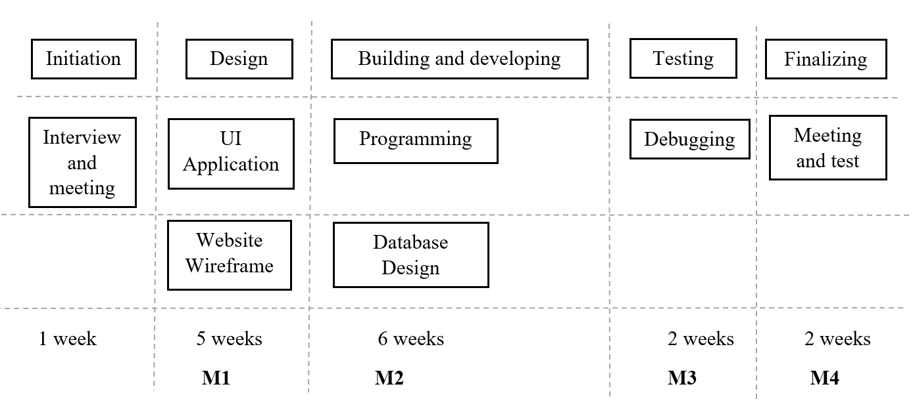

Figure 1 The Main Activities

## Phase 1: Initiation

Activity: Interview and meeting

1. Interview with client and mentor
2. Meeting with group members
3. Logo and name of the company

Estimated duration is one week.

## Phase 2: Design

Activity: Application GUI, website wireframe and database design

1. Make application GUI
2. Finish the website wireframe, e.g HTML.
3. Database design

Estimated duration is five weeks.

Deliverables for milestone **M1** are:

* Application GUI
* Website wireframe
* ERD(Entity Relationship Diagram)

## Phase 3: Building and developing

Activity: Programming

1. Add functionalities to application
2. Add functionalities to website

Activity: database design

1. Make ERD(Entity Relationship Diagram)
2. Create the database

Estimated duration is six weeks.

Deliverables for milestone **M2** are:

* Application with functionalities
* Website with functionalities

## Phase 4: Testing

Activity: Debugging

1. Find possible bugs
2. Fix the bugs

Estimated duration is two weeks.

Deliverables for milestone **M3** are:

* Prototype of application

## Phase 5: Finalizing

Activity:

1. Test the application in working environment
2. Meeting with client and discuss if client is satisfied with the products

Estimated duration is two weeks.

Deliverables for milestone **M4** are:

* The finished application and website